**FORTE LARYÓ**

***“Craftmanship you see, strength you can feel.***

***A foundation that lasts a lifetime.”***

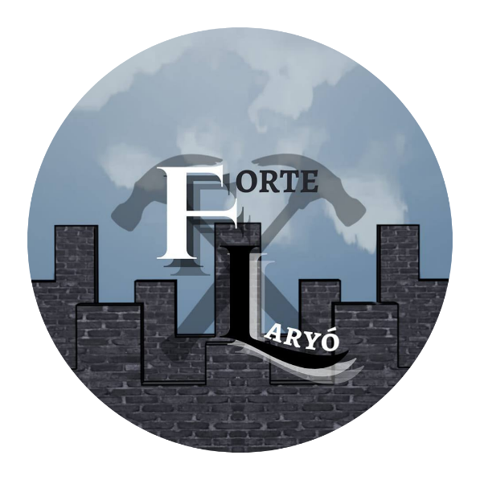

Business Plan Development

Presented to the Faculty of STI College Novaliches

Diamond Avenue corner Quirino Highway, San Bartolome,

Novaliches, Quezon City

May 2024

Science, Technology, Engineering, and Mathematics

Grade 12

STI College Novaliches

Avila, Kristine Mae C.

Bale, Maria Sophia P.

Beñoza, Jaimebelle R.

Bona, Cria Gayle L.

Brazil, Kassandra M.

Carpeso, Allison Kate F.

Cruz, Christian Thomas Rain O.

Decena, Regiette P.

Demalata, Jasmin Ann G.

Dumancas, Psalm David B.

Gutib, Mariz J.

Repollo, Ma. Fiona Angeline A.

Valdez, Jackie Lorraine I.

Batangas City, Batangas, Philippines

+63 995 674 1250/ fortelaryo.company@gmail.com

**CERTIFICATION**

This study entitled ***Name of Company*** prepared and submitted by ***Avila, Kristine Mae C., Bale, Maria Sophia P., Beñoza, Jaimebelle R., Bona, Cria Gayle L., Brazil, Kassandra M., Carpeso, Allison Kate F., Cruz, Christian Thomas Rain O., Decena, Regiette P., Demalata, Jasmin Ann G., Dumancas, Psalm David B., Gutib, Mariz J., Repollo, Maria Fiona Angeline A., Valdez, Jackie Lorraine I.*** partial fulfillment of the requirements for the strand **Science, Technology, Engineering, and Mathematics** has been examined and recommended for **Oral Examination.**

**Evaluation Committee**

**Mr. Mark Angelo Manalang**

**Adviser**

**________________________________________________________________________**

**APPROVAL**

It was approved by the **Panel on Oral Examination** on *___ day of ____ 2023* with the grade of _____.

**Ms. Ester Espiritu, LPT, MBA**

**Chairman**

**Mr. Mark Andrew Almazar Mr. Sylvester John Navarro**

**Member Member**

Accepted in partial fulfillment of the requirements for the strand **Science, Technology, Engineering, and Mathematics.**

**Ms. Sharmaine Joy Villaseñor, LPT**

Assistant Principal

**Ms. Judith Sindico, LPT**

Principal

**TABLE OF CONTENTS**

**Page**

i

**Title Page**

iii

**Certification**

iii

**Table of Contents**

v

**Executive Summary**

1. **Organization and Management Background**
   1. Business Profile

1

* + 1. Vision Statement

1

* + 1. Mission Statement

1

* + 1. Core Values

2

* + 1. Name of the Company

2

* + 1. Contact Information

3

* + 1. General Business Information
  1. Organizational Chart and Management Team

6

1.2.1 Organizational Chart

7

1.2.2 Management Team

1. **Production and Operation**

10

* 1. Product / Service Description

11

* 1. Product / Service Development Flowchart

12

* 1. Technology Consideration

13

* 1. Major Start-Up Needs

15

* 1. Business Operating Workflow

1. **Market Dimensions**
   1. Market Analysis

17

* + 1. Market Research
  1. Micro and Macro Environmental Analysis

18

3.2.1 Competitors Analysis

19

3.2.2 PESTLE Analysis

20

3.2.3. SWOT Analysis

3.3 Marketing Strategies

20

3.3.1 Unique Selling Proposition and Value Proposition

3.3.2 Pricing Strategy

21

22

3.3.3 Distribution Strategy

3.3.4 Advertising and Promotional Strategy

23

**IV. Financial Plan**

26

4.1 Capital Expenditures (Start-Up Capital)

27

4.2 Capital Contribution

29

4.3 Operating Expenditures

30

4.4 Income Statement

32

4.5 Payback Period

32

* 1. Return on Investment

1. **Appendices**

5.1 Partnership Agreement/ Company Bylaws and other legal requirements documents.

5.2 Description of the logo and other promotional paraphernalia.

5.3 Survey and other related market research.

5.4 Management Schedule and other management activities.

**EXECUTIVE SUMMARY**

Forte Laryó is an ecopreneurship company that focuses on ecological and economic sustainability. The company are dedicated to producing eco-friendly and affordable geopolymer bricks, which uses recycled materials to minimize negative environmental impact, and lower the carbon dioxide emissions in our country. This environmentally friendly strategy not only deals with environmental concerns, but also supports sustainable construction methods.

The product, "Geopolymer Bricks" utilizes discarded materials such as limestone, tarpaulin, glass bottles, and plastic wrappers as aggregates. Compared to a traditional brick, the company used fly ash to produce a cheaper brick. The production of Geopolymer Bricks starts when the company received and checked the raw materials. Afterwards, combining the materials; pulverized glass, fly ash, limestone, shredded tarpaulin, and plastic wrappers, then letting it dry. They propose the product to be tested by several tests such as drop and compression tests. If the brick passes these tests, it is ready to be distributed and sold to the customers. For the product to be successfully deemed an eco-friendly, and an alternative of standard bricks, Forte Laryó’s geopolymer bricks will be sold both in retail and wholesale for 12 pesos a piece. It can be lowered by 10% with a minimum purchase of 50 pieces.

In order to execute a product that is beneficial to the environment; Forte Laryó has a Management Team consists of thirteen (13) individuals who has the right skills and expertise on their respective departments: Financial, Operation, HR Management and Sales Marketing. The Sales Marketing Team of Forte Laryó, will promote the product through online advertising, referral program and joint promotions. The company intend to combine both online and offline promotional strategies to increase awareness, educate consumers, and generate demand for environmentally friendly geopolymer bricks.

The Forte Laryó SWOT Analysis states the strengths, weaknesses, opportunities and threats of the company and its product "Geopolymer Bricks". The product is eco-friendly, and sustainable. But their availability is limited; they are not well-known; construction can be time-consuming; and materials may be lacking. Despite the many threats the company face from existing competitors and the company's financial difficulties, there are still many opportunities for them, because of the product's low price, more industrial orders are expected. The product is also easy to upgrade and has a reduced negative environmental impact.

The company also analyzes the external factors that can affect the business in the near future, through PESTLE Analysis. In the Political section, it factors in government subsidies and incentives that can affect the business strategy and competitiveness. In the Economic category, the cost of inputs is considered. As for the Social section, increasing environmental awareness can lead to growing demand of the product. In terms of Technological category, by shifting towards digital avenues of marketing and interaction, the company can take advantage of it in targeting the right customers for the product. While, legal problems such as The Health and Safety Regulations should always be observed in the company, especially when the laborers are working on a product that contains substances that can be dangerous. Lastly, Forte Laryó would follow the Environmental Laws and Regulations to provide alternative plastic, tarpaulin and glass waste disposal by recycling them.

The startup capital of Forte Laryó was ₱2,651,075. This amount was used to purchase office supplies and equipment. Each member has invested into the project, which is equivalent to a total of ₱9,000,000. On the first year of launching, Forte Laryó generates ₱₱6,903,351.7 net income.

**I. Organization and Management Background**

**1.1 *Vision, Mission, and Core Values***

**1.1.1** Vision Statement

We envision a future where every building project prioritizes environmental responsibility without compromising on quality and performance, and where our products play an important role in shaping a greener and more resilient built environment for generations to come.

**1.1.2** Mission Statement

To produce eco-friendly and affordable geopolymer bricks, leveraging recycled materials to pioneer sustainable construction practices and minimize environmental impact, while fostering mutually beneficial relationships with customers, suppliers, and employees to achieve shared success and contribute positively to society.

**1.1.3** Philosophy/Core Values

FORTE LARYÓ is a company that produces eco-friendly bricks. Their goal is to provide customers with sustainable materials by keeping the price low while the quality of the product is high.

* Improve sustainability: use eco-friendly materials and practices in the production process.
* Prioritize Integrity: It is at the heart of the business, ensuring transparency, honesty, and ethical behavior in all the interactions.
* Adopt and espoused: drives to continuously improve the products and processes to benefit both the customers and the environment.
* Value Community: striving to make a positive impact on society through the sustainable practices and by promoting strong relationships with stakeholders.

**1.1.4** Name of Company

The name of the company " FORTE LARYÓ" derived from the quality and the durability of the product they are offering. The word "forte" is a Spanish word that means "strong", and the word "laryó" is a Filipino word that means "brick".

Forte Laryó offers an environmentally friendly geopolymer bricks using recycled materials for sustainable construction. The company’s vision is building projects to prioritize environmental responsibility while maintaining quality and performance.

**1.1.5** Contact Information

* Email address: [fortelaryo.company@gmail.com](mailto:fortelaryo.company@gmail.com)
* Cellphone number: +63 995 674 1250
* Social Media Account:

- Facebook Page: Forte Laryó

- Tiktok: forte_laryo

- Instagram: forte_laryo

- Website: <https://fortelaryocompany.wixsite.com/fortelaryo>

**1.1.6** General Business Information

Forte Laryó is involved in an ecopreneurship company that focuses on ecological and economic sustainability by the production of geopolymer bricks made from recycled materials like fly ash, limestone, tarpaulin, pulverized glass, and plastics. This environmentally friendly strategy not only deals with environmental concerns but also supports sustainable construction methods. Forte Laryó shows the ecopreneurship business by utilizing waste resources to create practical building components.

In terms of ownership, Forte Laryó is structured as a corporation, providing legal separation between the company and its owners. This means that the business operates independently from its shareholders, offering limited liability protection. This structure allows for easier transfer of ownership, potential tax benefits, and enhanced access to capital through stock issuance. By operating as a corporation, Forte Laryó can conduct business with clear ownership and governance frameworks, ensuring legal protection for its stakeholders.

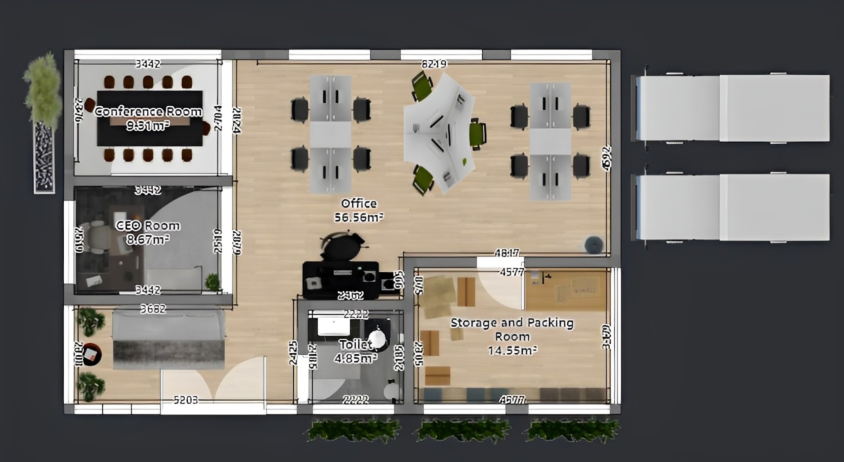***Figure 1:*** Top view of Forte Laryó’s floorplan

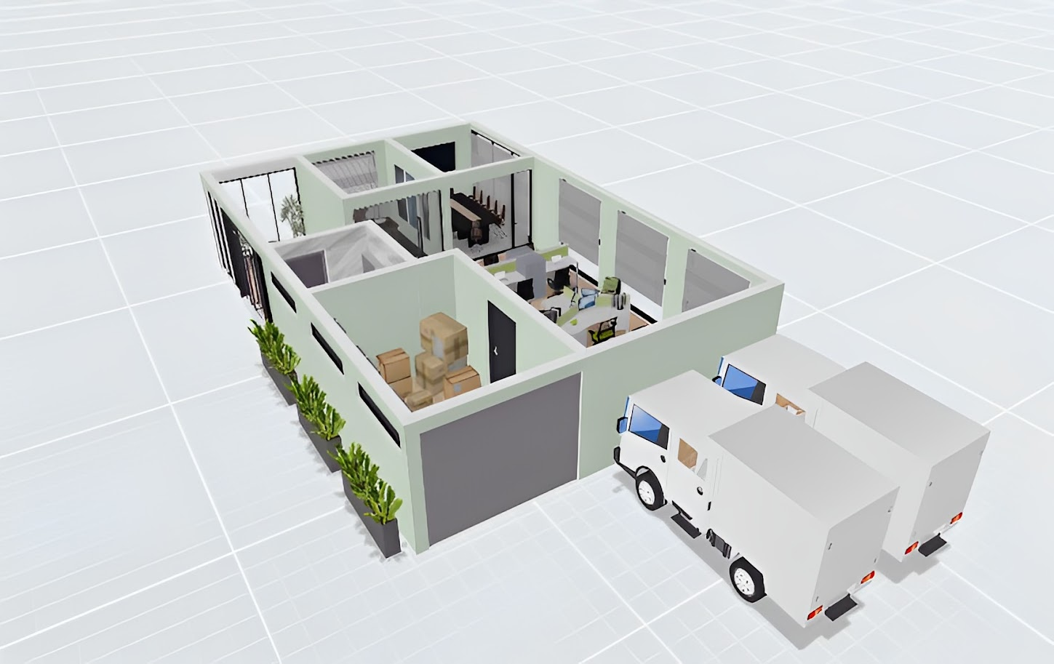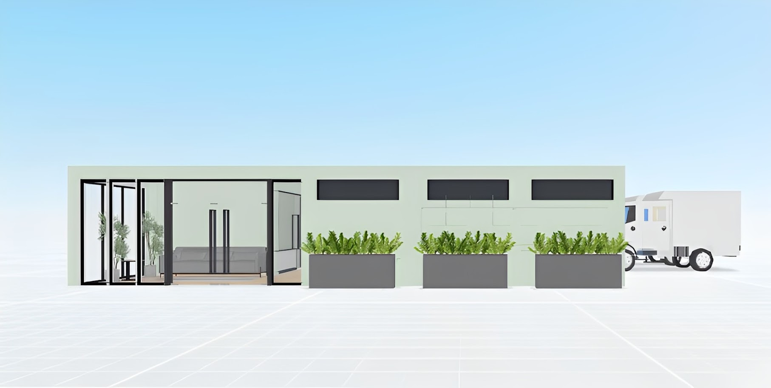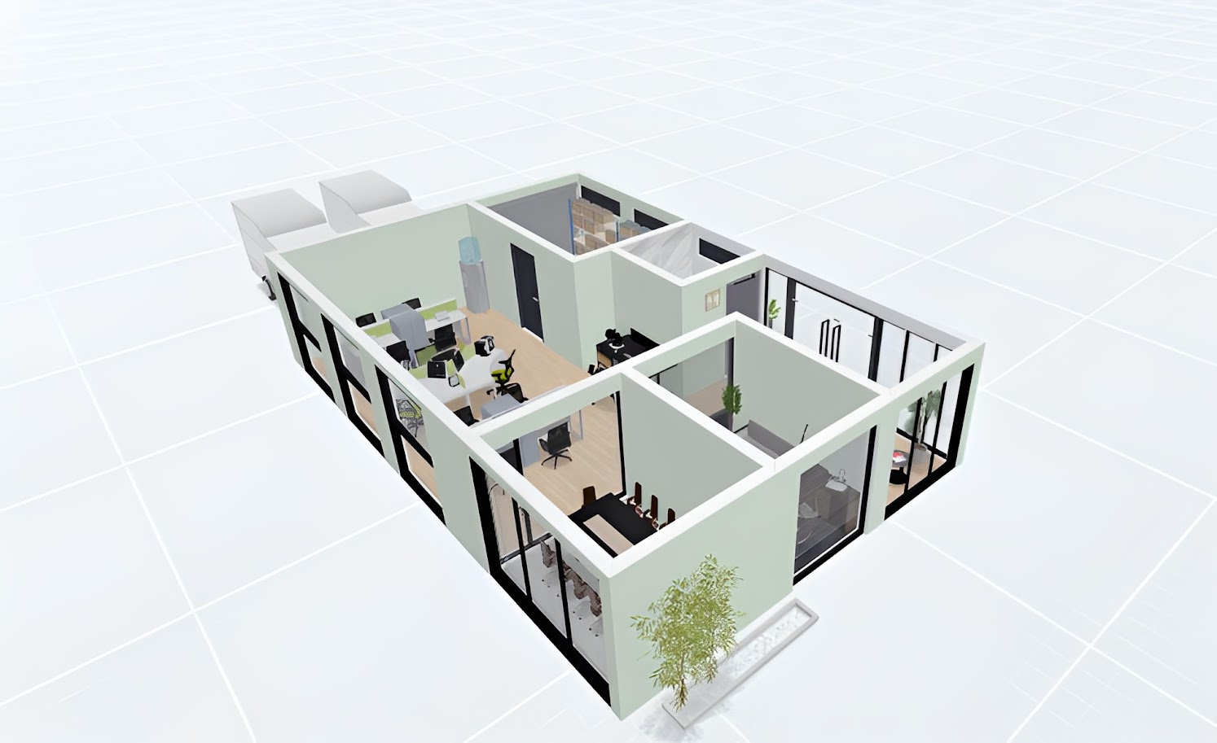

***Figure 3:*** Right Angled view of Forte Laryó’s floorplan

***Figure 2:*** Front view of Forte Laryó’s floorplan

***Figure 4:*** Left Angled view of Forte Laryó’s floorplan

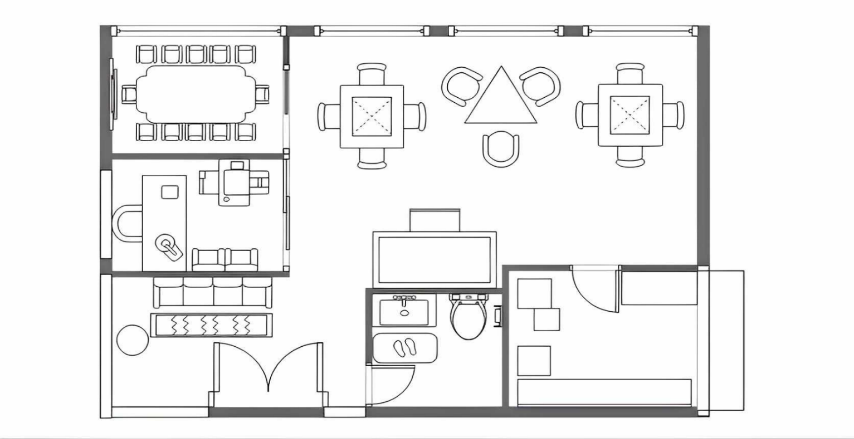

***Figure 5:*** Simple floor plan of Forte Laryó

***Figure 3:*** Angled view of Forte Laryó’s floorplan

**1.2 *Organizational Chart and Management Team***

**1.2.1** Organizational Chart

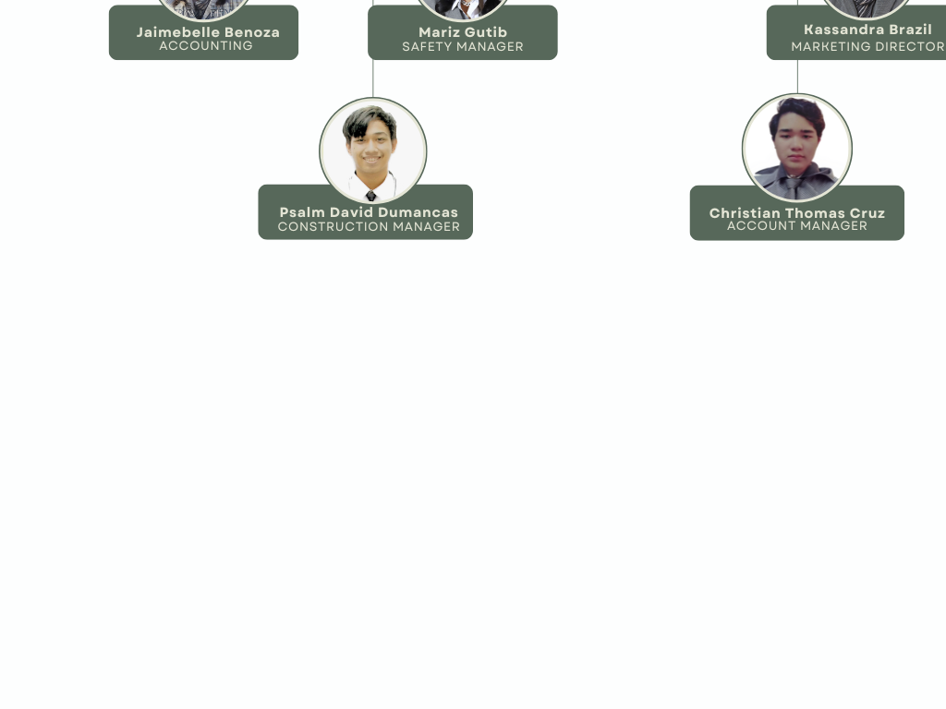

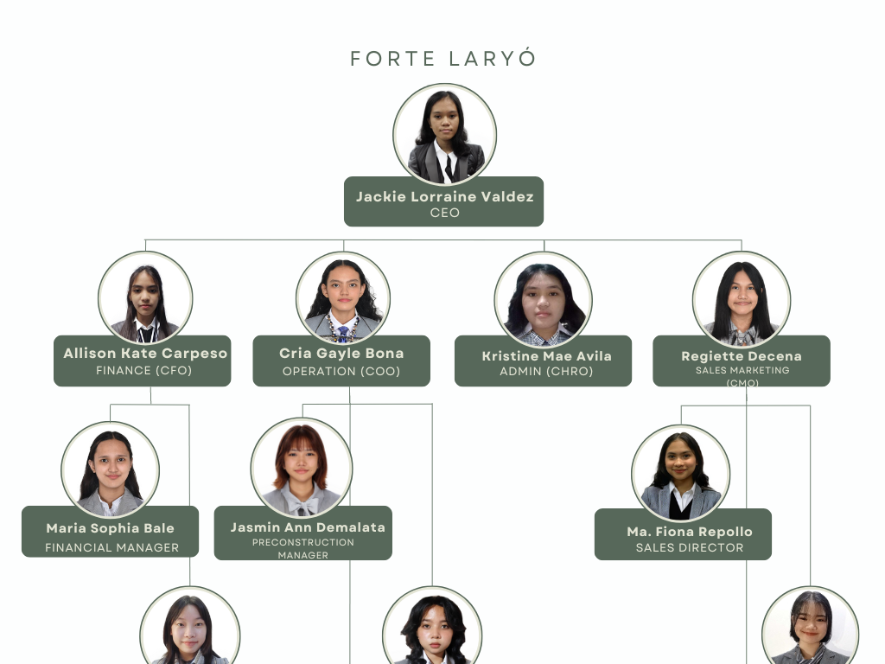

***Figure 6:*** Organizational Chart of Forte Laryó

**1.2.2** Management Team

**FINANCIAL DEPARTMENT**

|  |  |  |
| --- | --- | --- |
| **NAME** | **POSITION ON TEAM** | **DUTIES** |
| Carpeso, Allison Kate F. | Chief Financial Officer | Planning, implementing, managing, and running all the finance activities of a company. |
| Bale, Maria Sophia P. | Financial Manager | Responsible for the company's financial health, financial reports, budgeting, planning taxes, etc. |
| Beñoza, Jaimebelle R. | Accounting | Preparing and examining financial records and ensuring information is up-to-date and accurate. |

**OPERATION DEPARTMENT**

|  |  |  |
| --- | --- | --- |
| **NAME** | **POSITION ON TEAM** | **DUTIES** |
| Bona, Cria Gayle L. | Chief Operations Officer | Managing and handling the daily business operations, developing company policies, monitoring compliance, and overseeing projects and budgets. |
| Demalata, Jasmin Ann G. | Preconstruction Manager | Developing project budgets and schedules, including detailed cost estimates and construction schedules. |
| Gutib, Mariz J. | Safety Manager | Plans, implements, and conducts preventive care, safety, and compliance training programs |
| Dumancas, Psalm David B. | Construction Manager | Overseeing all the logistics of a construction project. |

**HR MANAGEMENT**

|  |  |  |
| --- | --- | --- |
| **NAME** | **POSITION ON TEAM** | **DUTIES** |
| Avila, Kristine Mae C. | Chief Human Resources Officer | Recruiting, managing, and retaining a business talent, making evaluations of employee performance, and being responsible for all HR functions of the company. |

**SALES MARKETING DEPARTMENT**

|  |  |  |
| --- | --- | --- |
| **NAME** | **POSITION ON TEAM** | **DUTIES** |
| Decena, Regiette P. | Chief Marketing Officer | Planning, developing, and executing of company’s marketing and advertising initiatives. |
| Repollo, Ma. Fiona Angeline A. | Sales Director | Designing plans to meet targets, developing relationships with clients/customers, and evaluating costs for selling products and services. |
| Brazil, Kassandra M. | Marketing Director | Developing and implementing marketing communications strategy, as well as branding activity within their company. |
| Cruz, Christian Thomas Rain O. | Account Manager | Developing strong relationships with customers, connecting with key business executives and stakeholders, and preparing sales reports. |

***Table 1:*** Management Team of Forte Laryó

**II. Production and Operation Aspect**

**2.1 *Detailed Product / Service Description***

The geopolymer bricks is an eco-friendly alternative for the common brick. This brick utilizes discarded materials such as tarpaulin, glass bottles, and plastic wrappers as aggregates. The geopolymer brick substitutes cement for fly ash, and limestone to be cheaper for costumers. The brick will measure 20cm x 9cm x 6cm and weigh 1 ¾kg.

Forte Laryó’s geopolymer bricks will be sold both in retail and wholesale. For the retail it will be 12 pesos a piece. The price can be lowered by 10% with a minimum purchase of 50 pieces. Thus, the price of a 50-piece purchase would be 540 pesos instead of 600 pesos. Forte Laryó also offers a 20% discount for 200-piece brick purchase, lowering the price from 2,400 pesos to 1,920 pesos.

Geopolymer bricks bought in bulk will be delivered by the company’s delivery trucks. Forte Laryó also offers compensation for good damaged during delivery through monetary refunds or replacements, granted only if the customer provides proof of the damaged product and return the faulty item back to the company.

The product has suppliers for its raw materials. For fly ash, the first supplier is 'Bennie’s Grill House' and the second is 'BBQ Lyn.' For limestone, the suppliers are 'PMAD Trading' and 'Aditha’s Farm Supply.' For pulverized glass, the suppliers are 'R.M.M Junkshop' and 'Ariel Junkshop.'

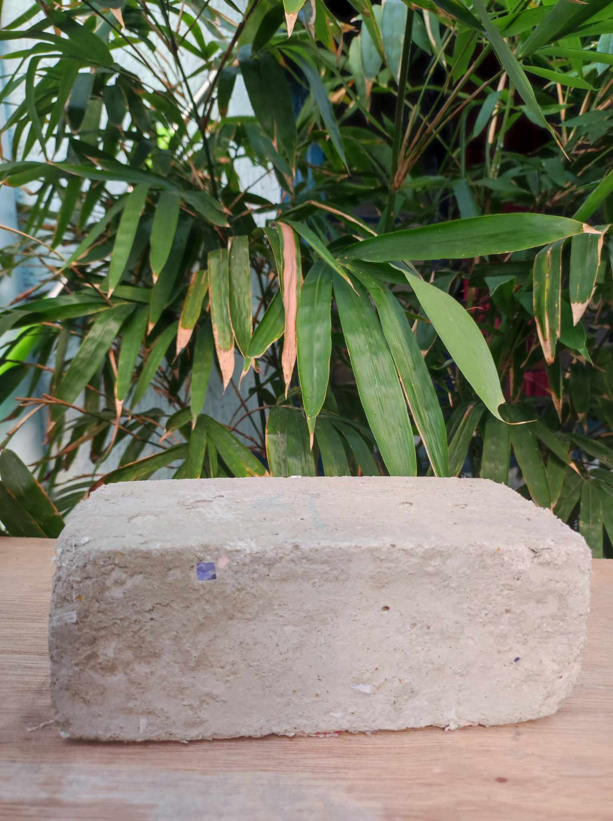

***Figure 7:*** Product prototype

**2.2 *Product / Service Development Flowchart***

***Product / Service Development Flowchart***

Receive raw materials

Yes

No

Distribute product

Passed

Reject product

Passed

Drop test

Combine raw materials

Reject raw materials

Accept raw materials

Compression test

No

No

Yes

Yes

***Figure 8:***Product Flowchart

**2.3 *Technology Consideration***

FORTE LARYÓ’s technology considerations focus on developing greater services and more convenience for the customers, hence, web-based applications specifically social media applications already serve this goal and still aim to develop other technology considerations besides the web-based ones. The following are areas of consideration in developing the use of technology on the product:

* **Cybersecurity Software:** Even though larger companies face a higher risk of cyberattacks, all businesses, including growing ones, should invest in cybersecurity. Businesses that rely on network infrastructure, regardless of size, are vulnerable if not properly protected.
* **Financial Management Tools:** Investing in financial management tools allows to easily and early monitor cash flow, track expenses, and manage employee payroll, all necessary steps to business success.
* **Customer Relationship Management (CRM) System:** A CRM system is designed to manage interactions and communications with existing and potential customers. In investing in this system, it would be easier for the inquiries of customers to be addressed immediately.

By implementing these technological considerations, the company aim to further strengthen the business and provide an even better experience for the customers.

**2.4 *Major Start-Up Needs***

Forte Laryó needs to maintain the quality and quantity of the bricks for a successful start-up. To achieve this, several key materials and resources are required to ensure consistent production and high standards.

|  |  |  |
| --- | --- | --- |
| **MATERIALS** | **FUNCTION** | **AMOUNT** |
| * White Limestone Powder, Packaging Size: 50 kg at Rs 6000/tonne in Mumbai |  ID: 21006257430Limestone (Calcium Oxide) | * It acts as a source of calcium, essential for the formation of geopolymer compounds, thereby contributing to the strength and durability of the bricks. | * ₱17.00 per kilo. * ₱56,678 for 3,334 kilos, production of 10,000 bricks. |
| * Fly ash   Fly Ash - Uses, Properties, Classification and Advantages - Civil Wale | * It serves as a source of alumina and silica, which are key components in the geopolymerization reaction, resulting in bricks with excellent strength and durability. | * ₱0.50 per kilo. * ₱1,667 for 3,334 kilos, production of 10,000 bricks. |
| * Glass bottles   Glass Bottle Recycling Adelaide | * Glass bottles undergo a transformation process to become pulverized glass, offering an eco-friendly alternative to sand. | * ₱0.50 per bottle. * ₱2,500 for 5,000 pieces of bottles, production of 10,000 bricks |
| * Sifter | * help separate pulverized glass from shattered glass through filtration. | * ₱780 |
| * Product image ☫Plastic Waste Shredder Metal Plastic Shredder Machine In Malaysia Industrial Paper Plastic And MDPlastic waste shredder | * The plastic waste shredder efficiently breaks down plastic waste into smaller pieces. | * ₱99,999 |
| * Concrete block making machinery | * utilized to produce bricks in bulk. | * ₱285,229 |
| * Glass to Sand CrushersGlass crusher | * Used to pulverize the glass bottles finely. | * ₱10,226 |

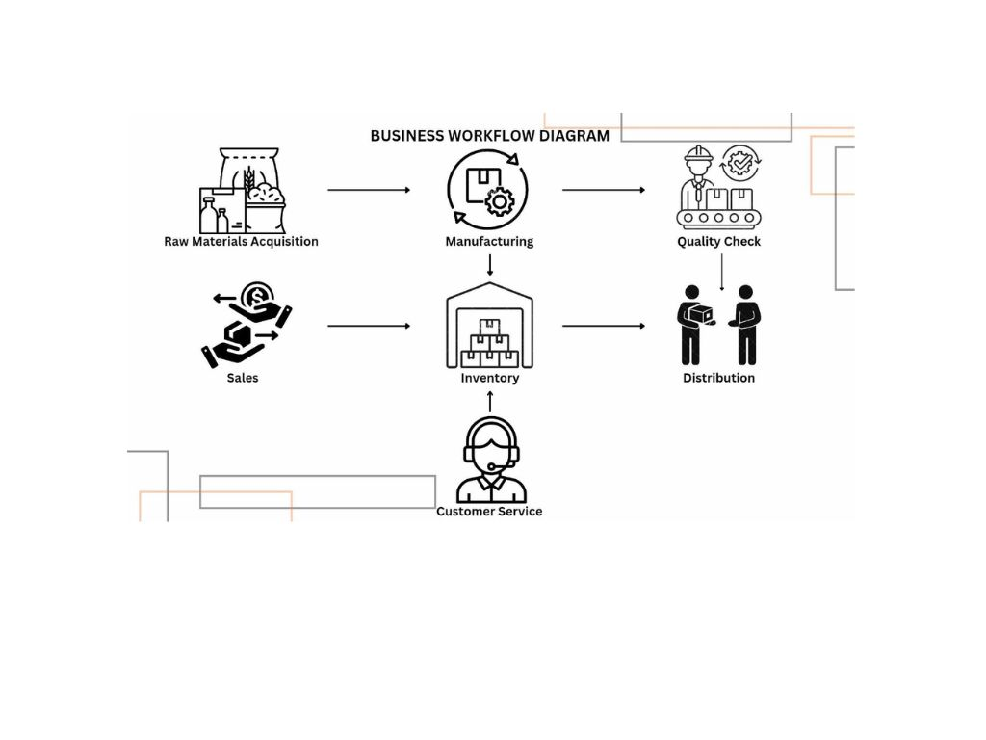**2.5 *Business Operating Workflow***

***Figure 9:***Business Operating Workflow of Forte Laryó

The company’s business workflow details these factors: The acquisition of raw materials, a quality check, distribution, inventory, sales, and customer service. The raw materials are collected in two manners, buying from distributors, or through promotional events the company arranges that takes advantage of willing participants that want to contribute waste materials. The materials in question are Fly ash, Calcium Oxide (Lime), plastic wastes, glass wastes, and discarded tarpaulins. After the materials are secured, we advance the process to manufacturing our bricks. In which the raw materials would be processed, mixed, molded, and cured into bricks by our machines. The bricks would be stored in the company’s warehouses indefinitely until delivery. The surplus of products will also be stored in the company’s inventory.

Afterwards, a quality check will be conducted to ensure that the product fits in the standards of the company. If the product is deemed acceptable, it will be available to distribution. Sales affect inventory in a direct manner, inventory levels rise if production exceeds sales and falls if sales if exceed production. It is of utmost importance the two elements are balanced. The relationship between inventory and customer is also direct, proper management of the company’s inventory ensures that products are always in supply. This relationship dictates the customer’s impression of the company and their retention; The lack of supply would ward off customers, and the availability of the product supplies ensures the customers would be satisfied and encourages them to return for future purchases.

**III. Market Analysis**

**3.1 *Market Dimensions***

**3.1.1** Market Research

Geopolymer bricks provides a sustainable alternative to the standard fired bricks we commonly use today. There is a study, that study prove that the manufacturing cost of geopolymer bricks provides an economic gain of 5% compared to common fired bricks for the same compressive strength of 20 MPa. In the case of waste bricks, for the same production cost, the compressive strength of the geopolymer bricks is doubled the strength of fired bricks. Hence, the study shows the economic interest in the industrial production of geopolymer bricks. It also confirms that future research is needed that focuses on necessary changes to the current industrial production chain required for the manufacture of geopolymer bricks (Youssef et al., 2020).

With our fast-growing economy, buildings are fast rising, the market research shows that geopolymer bricks have a lot of opportunity for variety of industries, that are real estate, business, infrastructure projects. The construction industries are switching and focusing on the geopolymer bricks value proposition because of their sustainability, making them an affordable product. The production of geopolymer concrete also will significantly lower the carbon dioxide emissions compared to traditional Portland cement-based concrete, this will provide economic growth, plus environmental benefit.

**3.2.1** Competitor Analysis

A. Direct Competitors

|  |  |  |  |
| --- | --- | --- | --- |
|  | Artisano Kabalan  (hollow brick) | Bricco  (concrete bricks) | Allied Concrete Products Inc.  (hollow blocks) |
| Price | ₱ 40 – 65 / pc of hollow brick | ₱ 18 – 19/pc of brick, 45 – 50 pcs / sqm | ₱ 15 – 19/pc of hollow block, 45 – 50 pcs / sqm |
| Quality | * Low maintenance, appearance and texture changes upon application of stains, sealers | * High fire resistant * No salinity, reduces maintenance cost * Withstand high level loading * High durability * Compacted by high pressure and vibration | * Insulating * Energy cost-saving bricks |
| Durability | Withstand 600+ PSI | Withstand 700+ PSI | Withstand 350 – 1200 PSI |

B. Indirect Competitors

|  |  |  |  |
| --- | --- | --- | --- |
|  | Santa Clara Marine Plywood (Plywood) | Bricco  (Bamboo) | GT Stone Works  (stone cladding) |
| Price | ₱ 925.00 – 2,833.25 /pc of plywood | ₱ 600.00 – 900.00 / per bundle of bamboo | ₱ 950.00 – 2,100.00 / sqm |
| Quality | * Compressed * Authentic materials | * High grade bricks * Lighter than other wood | * More lightweight |
| Durability | * Thick | * Stronger than steel * Durable | * Stable |

Table **2:** Competitor Analysis of Forte Laryó

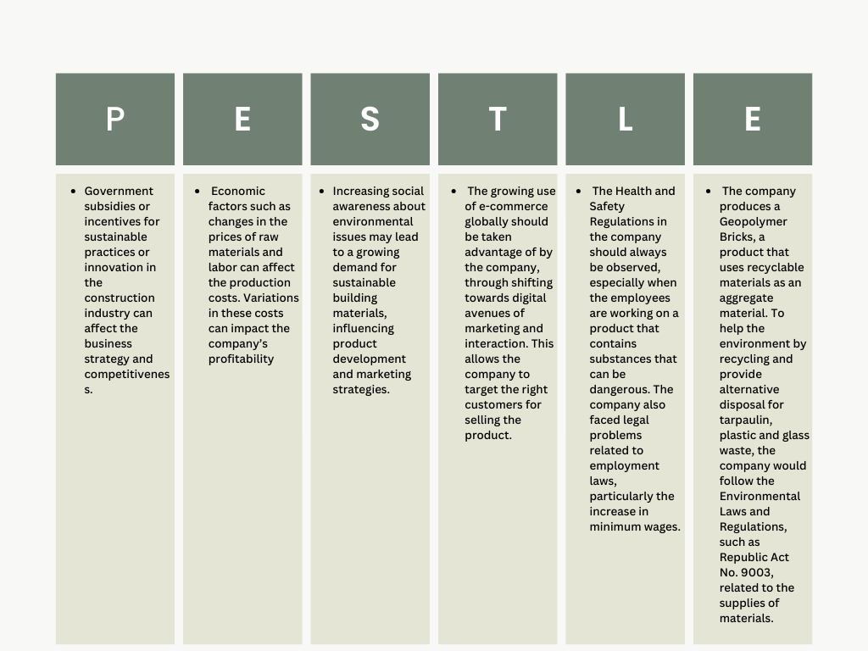**3.2.2** PESTLE Analysis

***Figure 10:***PESTLE Analysis of Forte Laryó

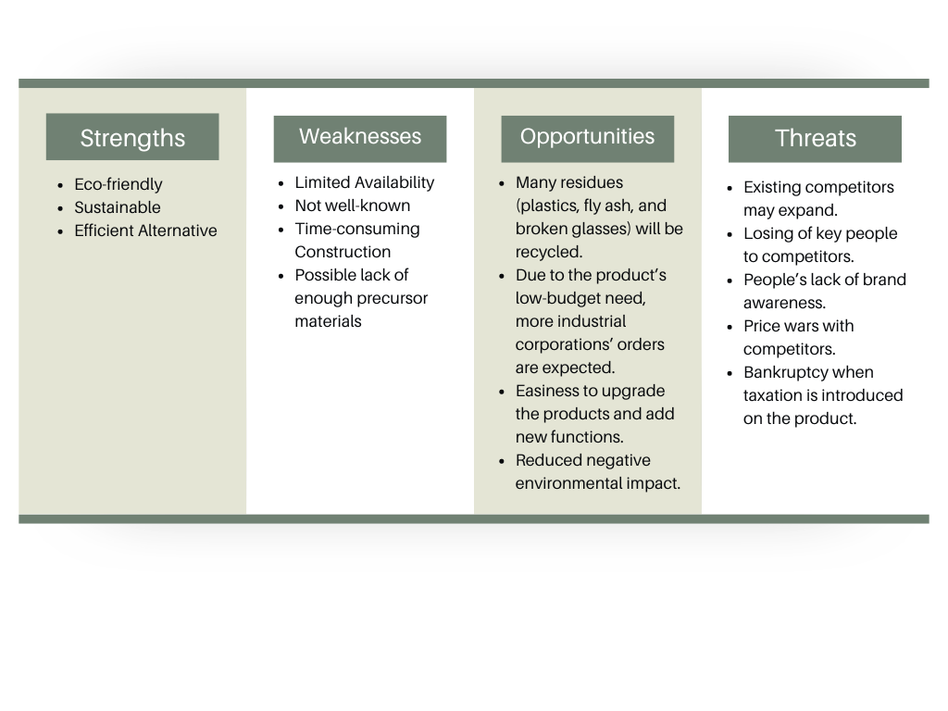**3.2.3** SWOT Analysis

***Figure 11:***SWOT Analysis of Forte Laryó

**3.3 *Marketing Strategies***

**3.3.1** Unique Selling Proposition and Value Proposition

The geopolymer bricks are not only eco-friendly but also use a unique combination of discarded materials such as tarpaulin, glass bottles, and plastic wrappers as aggregates. By using fly ash, and limestone instead of cement, the company produces environmentally friendly bricks.

1. Environmental sustainability: The geopolymer bricks’ eco-friendly qualities will attract customers who are concerned about lessening their influence on the environment.
2. Cost-effective: The company can provide consumers with a more economical option because Forte Laryó uses fly ash instead of cement and recycled materials, which makes it a good choice for people on a tight budget or companies.
3. Unique materials: The geopolymer bricks stand out from conventional solutions because of the use of recycled materials as aggregates, such as glass bottles and plastic wrappers. This makes them appealing to individuals searching for something different and unique for their construction projects.

**3.3.2** Pricing Strategy

1. **Direct Materials Cost**

|  |  |  |  |  |
| --- | --- | --- | --- | --- |
| **Raw Materials** | **Unit Measurement** | **Amount** | **Estimated Unit Produced** | **DM Cost/Unit** |
| Limestone | 3,334 kg | ₱56,678 | 10,000 | ₱5.6678 |
| Glass Bottle | 5,000 bottles | ₱2,500 | 10,000 | ₱0.25 |
| Fly Ash | 3,334 kg | ₱1,667 | 10,000 | ₱0.1667 |
| **Total DM Cost/Unit** |  | ₱60,845 | 10,000 | ₱6.0845 |

1. **Direct Labor**

|  |  |  |  |
| --- | --- | --- | --- |
| **Direct Labor** | **Amount** | **Target Sales** | **DL Cost/Unit** |
| Salaries and Wages | ₱5,500 | 10,000 | ₱0.55 |
| Insurance | ₱4,166.70 | 10,000 | ₱0.41667 |
| Total DL/Unit | ₱9,666.70 | 10,000 | ₱0.96667 |

1. **Overhead Cost**

|  |  |  |  |
| --- | --- | --- | --- |
| **Overhead Cost** | **Amount** | **Target Sales** | **OC/Unit** |
| Electricity | ₱7,066 | 10,000 | ₱0.7066 |
| Water | ₱274 | 10,000 | ₱0.0274 |
| **Total OC/Unit** | ₱7,340 | 10,000 | ₱0.734 |

1. **Total Cost/Unit**

|  |  |  |  |
| --- | --- | --- | --- |
| **DM Cost** | **DL Cost** | **Overhead Cost** | **Total Cost/Unit** |
| ₱6.0845 | ₱0.96667 | ₱0.734 | ₱7.78517 or ₱8 |

**II. PRICING**

|  |  |  |  |
| --- | --- | --- | --- |
| **Total Cost/Unit** | **Mark Up %** | **Mark Up** | **Price Per Unit** |
| **₱8.00** | **50%** | **₱4** | **₱12.00** |

* + 1. Distribution Strategy

The marketing strategies that will apply to the business plan are online advertising, referral program, and joint promotions.

1. Online advertising. Since the company has its own social media accounts and website, it would be easier for them to find target customers or companies that would want to try new materials. It also can reach other countries since social media is used globally. It is also a low-cost advertisement because social media is free which is very helpful for the company. It is also convenient because the Internet is easily accessible to consumers. The company can easily get some feedback too.
2. Referral program. The other company or reseller will refer the product to others so they can attract customers easily. It will also result in higher retention since several studies show that the product that is referred by someone is more likely to stay with your product. It will also create loyal customers since referral builds trust.
3. Joint promotions. In joining promotions, it will be easy to find target customers since promoting makes the product, services and brand known. If some company likes the product, there is a chance that collaboration will happen and make the business more known.
   * 1. Advertising and Promotional Strategy

The **marketing strategy** for Forte Laryó is focused on utilizing the potential of social media and distributing flyers to effectively connect with their target consumers and promote geopolymer bricks. The primary objectives are:

1. To increase market awareness – raise awareness among consumers and businesses about the availability and benefits of the geopolymer bricks as an eco-friendly alternative to traditional bricks.
2. Educate on sustainability – educate consumers about the environmental benefits of using geopolymer bricks
3. Promote cost savings – the geopolymer bricks offer a cost-effective solution compared to traditional bricks by utilizing discarded materials, enabling consumers to save money.

**Advertising and Promotional Strategy**

Forte Laryó intend to combine both online and offline promotional strategies to increase awareness, educate consumers, and generate demand for the environmentally friendly geopolymer bricks.

1. Content Development – Through visually appealing posts, engaging videos, and informative infographics, the company will showcase the innovative features of the bricks, showing their sustainability and cost-effectiveness compared to traditional bricks.
2. Social Media Presence – With a focused presence on social media platforms like Facebook, the company will strategically disseminate information to connect with their target demographic. The platform will be utilized strategically to optimize engagement and interaction with the audience.
3. Flyers – In tandem with digital efforts, the company will distribute flyers in various strategic locations. These flyers will serve as tangible reminders of the geopolymer bricks’ benefits, prompting potential customers to seek further information.
4. Customer Interaction – Active engagement with audience through comments, addressing inquiries, and messages will create a sense of community and trust.
5. Government Partnership - Forte Laryó partners with government agencies that build infrastructure and provide affordable housing for the lower sector of our country. The following are the government agencies the company wants to have collaborations with:

* Department of Human Settlements and Urban Development
  + The Department is the sole and main planning and policy-making, regulatory, program coordination, and performance monitoring entity for all housing, human settlement, and urban development concerns, primarily focusing on the access to and affordability of basic human needs.
  + The regulatory function, including the formulation, promulgation, and enforcement of rules, standards and guidelines over subdivisions, condominiums and similar real estate developments, and imposition of fines and other administrative sanctions for violations, pursuant to PD 957, as amended, BP 220 and other related laws; and
* Housing and Real Estate Development Regulation Bureau
* National Housing Authority
  + We pledge to Building Adequate, Livable, Affordable, and Inclusive Filipino Communities (BALAI)
  + NHA shall continue to function as a production and financing arm in housing and shall exercise all other functions based on its existing laws.
* Department of Trade and Industry
* Construction Industry Authority of the Philippines
  + Promotes, accelerates, and regulates the construction industry through its various implementing boards.
* Department of Public Works and Highway
  + The Department of Public Works and Highways (DPWH) earlier said the fundamental objective of the program is to invest adequately in infrastructure to support and sustain the country’s growing economic activities represented by its gross domestic product (GDP).
* Build, Build Program
  + The Build! Build! Build! (BBB) Program is the centerpiece program of the Duterte administration that aims to usher the “Golden age of Infrastructure” in the Philippines. Lack of infrastructure has long been cited as the “Achilles’ heel” of Philippine economic development.

1. **Financial Plan**
   1. ***Capital Expenditures (Start-Up Capital)***

Forte Laryó

Capital Expenditure

Beginning Assets for Year 2024

|  |  |
| --- | --- |
| **Assets** | **Amount** |
| Building and Site Facilities | ₱700,000 |
| Machinery and Equipment | ₱415,906 |
| Furniture and Fixture | ₱51,144 |
| Office Equipment | ₱73,461 |
| Registration, Taxes, and Licenses | ₱14,719 |
| Contingency Funds | ₱1,300,000 |
| Working Capital Requirement | ₱60,845 |
| Other Legal Fees | ₱35,000 |
| **Total Project Capital** | ₱2,651,075 |

***Table 3:*** Capital Expenditures of Forte Laryó

*Notes:

* Under “Building and Site Facilities” includes two (2) trucks worth ₱700,000 in total.
* Under “Machinery and Equipment” includes glass crusher worth ₱10,226 x 3 = ₱30,678, and a concrete block making machinery worth $4,900, equivalent to ₱285,229, and a plastic waste shredder worth ₱99,999.
* Under “Furniture and Fixture” includes with their corresponding prices such as, desk- ₱11,687, chair- ₱3,822, table- ₱6,450, drawer- ₱6,350, shelf- ₱3,300, sofa- ₱9,535, toilet- ₱5,000, sink- ₱5,000.
* For “Office Equipment” includes the laptop for each department worth ₱12,495 a total of ₱62,475, and two (2) printer worth ₱5,495 with a total of ₱10,986.
* Registration, Taxes, and Licenses” includes SEC Registration expenses worth ₱6,750, DTI Registration worth ₱1,700, BIR Registration worth ₱530, Sanitary Permit worth ₱90, Fire Safety Inspection Fee worth ₱649, and Barangay Permit worth ₱5,000.
* The “Working Capital Requirement” includes 3,334 kg lime worth ₱56,678, worth ₱2,500 of 5,000 pieces of glass bottles, and ₱1,667 of 3,334 kg of fly ash in a 5,000 pieces of bricks production.
* For “Other Legal Fees” include a registration of ₱35,000 for a corporation to have a license.
  1. ***Capital Contribution***

|  |  |  |
| --- | --- | --- |
| **Proponents** | **Position** | **Contribution** |
| Avila, Kristine Mae C. | Chief Human Resources Officer | Cash Investment of ₱900,000 |
| Bale, Maria Sophia P. | Financial Manager | Cash Investment of ₱450,000 |
| Beñoza, Jaimebelle R. | Accounting | Cash Investment of ₱180,000 |
| Bona, Cria Gayle L. | Chief Operations Officer | Cash Investment of ₱1,350,000 |
| Brazil, Kassandra M. | Marketing Director | Cash Investment of ₱450,000 |
| Carpeso, Allison Kate F. | Chief Financial Officer | Cash Investment of ₱1,350,000 |
| Cruz, Christian Thomas Rain O. | Account Manager | Cash Investment of ₱180,000 |
| Decena, Regiette P. | Chief Marketing Officer | Cash Investment of ₱900,000 |
| Demalata, Jasmin Ann G. | Preconstruction Manager | Cash Investment of ₱450,000 |
| Dumancas, Psalm David B. | Construction Manager | Cash Investment of ₱450,000 |
| Gutib, Mariz J. | Safety Manager | Cash Investment of ₱270,000 |
| Repollo, Ma. Fiona Angeline A. | Sales Director | Cash Investment of ₱450,000 |
| Valdez, Jackie Lorraine I. | Chief Executive Officer | Cash Investment of ₱1,800,000 |
| TOTAL: | | ₱9,000,000 |

***Table 4:*** Capital Contribution of Forte Laryó

**4.2 *Operating Expenditures***

|  |  |  |  |  |  |  |  |  |  |  |  |  |
| --- | --- | --- | --- | --- | --- | --- | --- | --- | --- | --- | --- | --- |
| |  |  | | --- | --- | | **Operating Expenditures** | **Amount** | | Rent | ₱360,000 | | Salary Expense | ₱1,716,000 | | Utilities | ₱1,549,714 | | Internet Connection | ₱24,000 | | **TOTAL** | ₱3,649,714 | |
| ***Table 5***: Operating Expenditures of Forte Laryó   |  |  | | --- | --- | | **Pre-operating Expenditures** | **Amount** | | Bond paper | ₱510.00 | | Ballpen | ₱180.00 | | Folders | ₱560.00 | | Envelopes | ₱100.00 | | File holders | ₱480.00 | | Printer Ink | ₱1,300.00 | | Paper Clips | ₱100.00 | | Stapler | ₱330.00 | | **TOTAL** | ₱3560.00 |   ***Table 6***: Pre-operating Expenditures of Forte Laryó  **4.4 *Income Statement***  **Forte Laryó**  **Income Statement**  **January 2023 - December 2023**  Sales:  Net Sales ₱37,440,000  Less: Cost of Goods Sold ₱21,273,720  Gross Profit: ₱16,166,280  Expenses:  Pre-operating Expenditure  Operating Expenditure  Capital Expenditure    Total Expenses ₱6,304,349  Income before Tax (30%) ₱9,861,931  Less Tax (30%) ₱2,958,579.3  Net Income ₱6,903,351.7    ₱3,560  ₱3,649,714  ₱2,651,075  **Sales Forecast**   |  |  |  |  |  |  | | --- | --- | --- | --- | --- | --- | | **Items** | **A. Cost Per Unit** | **B. Markup Price** | **C. Selling Price** | **D. Items Sold (Daily)** | **E. Forecasted Revenue (Daily)** | |  | A | B= (A x .30) | C= A + B | D | E= C x D | | Geopolymer Bricks | ₱8.00 | ₱4.00 | ₱12.00 | 10,000 pieces | ₱120,000 |   ***Table 6:*** Forecasted Daily Revenue of Forte Laryó   |  |  |  |  |  | | --- | --- | --- | --- | --- | | **Items** | **C. Selling Price** | **D. Items Sold (Daily)** | **F. Projected Items Sold (Monthly)** | **G. Forecasted Revenue (Monthly)** | |  | C= A + B | D | F= D x 26 days | G= C x F | | Geopolymer Bricks | ₱12.00 | 10,000 pieces | 260,000 pieces | ₱3,600,000 |   ***Table 7:*** Forecasted Monthly Revenue of Forte Laryó   |  |  |  |  |  | | --- | --- | --- | --- | --- | | **Items** | **C. Selling Price** | **D. Items Sold (Daily)** | **H. Projected Items Sold (Annually)** | **I. Projected Revenue (Annually)** | |  | C= A + B | D | H= D x 312 days | I= C x H | | Geopolymer Bricks | ₱12.00 | 10,000 pieces | 3,120,000 pieces | ₱37,440,000 |   ***Table 8:*** Projected Annual Revenue of Forte Laryó  ***4.5 Payback Period***  Payback Period = Total Capital  Net Income  = 9,000,000  6,903,351.7  **= 1.30**  Therefore, it takes one (1) year and three (3) months to recover all the capital contributed by the partners.  **4.6 *Return on Investment***  Return on Investment = Net Profit  Cost of Investment  = 6,903,351.7  9,000,000  **= 76.70%**  100%  x  100%  x  Therefore, after one (1) year of operation it seems that 76.70% of the total capital contributed by the partners are recovered or payback based on the net income computed under the income statement and total contributed capital by all the partners. |

**V. Appendices**

***5.1 Partnership Agreement/ Company Bylaws and other legal requirements documents.***

General Partnership

**ARTICLES OF PARTNERSHIP**

**OF**

**FORTE LARYO**

## KNOW ALL MEN BY THESE PRESENTS:

That we, the undersigned partners, all of legal age, residents and citizens of the Philippines, have on this day voluntarily associated ourselves together for the purpose of forming a general partnership under the following terms and conditions and subject to existing and applicable laws of the Republic of the Philippines:

## AND WE HEREBY CERTIFY:

**ARTICLE I. Partnership Name:** That the name of this partnership

shall be Forte Laryó and shall transact business under the said company name.

**ARTICLE II. Business Purpose:** That the purpose/s for which this partnership is formed is/are: to produce eco-friendly and affordable geopolymer bricks using recycled materials to minimize environmental impact.

**ARTICLE III. Principal Place of Business:** That the principal place of business of this partnership shall be located at: Batangas City, Batangas.

**ARTICLE IV. Term of Existence:** That this partnership shall have a term of ­five (5) years from and after the original recording of its Articles of Partnership by the Securities and Exchange Commission.

**ARTICLE V. Partners’ Circumstances:** That the names, nationalities and complete residence addresses of the partners are as follows:

|  |  |  |
| --- | --- | --- |
| Name | Nationality | Complete Residence Address |
| Avila, Kristine Mae C. | Filipino | 160 Don Julio Gregorio, Sauyo Road, Novaliches, Quezon City |
| Bale, Maria Sophia P. | Filipino | 201 Mabuhay Compound, Sauyo, Quezon City |
| Beñoza, Jaimebelle R. | Filipino | No. 246 Amethyst Street, Greenheights Subdivision, Brgy. San Bartolome Novaliches Quezon City |
| Bona, Cria Gayle L. | Filipino | Block 8 Lot 25 Vista Verde North Executive Village, Caybiga, Caloocan City |
| Brazil, Kassandra M. | Filipino | Block 4 Lot 14 Kingdom 1 Subdivision Barangay Nagkaisang Nayon Novaliches Quezon City |
| Carpeso, Allison Kate F. | Filipino | B6 L17 Malaga Street, Sierra Vista Phase 3, Brgy. Nagkaisang Nayon Novaliches Quezon City |
| Cruz, Christian Thomas Rain O. | Filipino | Villa Hermano 4 Blk 2 Lot 17, Diamond Street, Sta.Lucia, Novaliches, Quezon City |
| Decena, Regiette P. | Filipino | Alley 4, Urcia St. Seminary Rd, Brgy. Bagbag, Novaliches, Quezon City |
| Demalata, Jasmin Ann G. | Filipino | Blk 6 Lot 9 West Los Angeles Street California Village, Brgy. San Bartolome, Novaliches Quezon City |
| Dumancas, Psalm David B. | Filipino | No. 2 Waling Waling st. Sampaguita Ave. Brgy. Pasong Tamo Quezon City |
| Gutib, Mariz J. | Filipino | 22 Molave Dr 1 Nagkaisang Nayon Novaliches Quezon city |
| Repollo, Ma. Fiona Angeline A. | Filipino | 19 Nenita Extension, RP Gulod, Novaliches, Quezon City |
| Valdez, Jackie Lorraine I. | Filipino | 26 Rosal St. San Pedro 9 Subd. Bagbag Novaliches, Quezon City |

**ARTICLE VI. Capital Contributions:** That the capital of this Partnership shall be the amount of Nine Million (₱9,000,000), Philippine Currency, contributed in cash by the partners, as follows:

|  |  |
| --- | --- |
| Name | Amount Contributed |
| Avila, Kristine Mae C. | Nine Hundred Thousand (₱900,000) |
| Bale, Maria Sophia P. | Four Hundred Fifty Thousand (₱450,000) |
| Beñoza, Jaimebelle R. | One Hundred Eighty Thousand (₱180,000) |
| Bona, Cria Gayle L. | One Million Three Hundred Fifty Thousand (₱1,350,000) |
| Brazil, Kassandra M. | Four Hundred Fifty Thousand (₱450,000) |
| Carpeso, Allison Kate F. | One Million Three Hundred Fifty Thousand (₱1,350,000) |
| Cruz, Christian Thomas Rain O. | One Hundred Eighty Thousand (₱180,000) |
| Decena, Regiette P. | Nine Hundred Thousand (₱900,000) |
| Demalata, Jasmin Ann G. | Four Hundred Fifty Thousand (₱450,000) |
| Dumancas, Psalm David B. | Four Hundred Fifty Thousand (₱450,000) |
| Gutib, Mariz J. | Two Hundred Seventy Thousand (₱270,000) |
| Repollo, Ma. Fiona Angeline A. | Four Hundred Fifty Thousand (₱450,000) |
| Valdez, Jackie Lorraine I. | One Million Eight Hundred Thousand (₱1,800,000) |

That no transfer of interest which will reduce the ownership of Filipino citizens to less than the required percentage of capital as provided by existing laws shall be allowed or permitted to be recorded in the proper books of the partnership.

**ARTICLE VII. Sharing Ratios:** That the profits and losses of this partnership shall be divided and distributed proportionately on the ratio of the capital contribution of each partner.

**ARTICLE IX. Management:** That this partnership shall be under **Ms. Jackie Lorraine I. Valdez,** as General Manager, who shall be in charge of the management of the affairs of the company. He shall have the power to use the partnership name and in otherwise performing such acts as are necessary and expedient in the management of the firm and to carry out its lawful purposes.

**ARTICLE X. Undertaking to Change Name:** That the partners undertake to change the name of this partnership, as herein provided or as amended thereafter, immediately upon receipt of notice or directive from the Securities and Exchange Commission that another corporation, partnership or person has acquired a prior right to the use of that name or that the name has been declared as misleading, deceptive, confusingly similar to a registered name, or contrary to public morals, good customs or public policy.

**IN WITNESS WHEREOF**, we have hereunto affixed our signatures this 10th day of May, 2024, at Quezon City.

|  |  |
| --- | --- |
|  |  |
| Avila, Kristine Mae C. | Carpeso, Allison Kate F. |
|  |  |
| Bale, Maria Sophia P. | Cruz, Christian Thomas Rain O. |
|  |  |
| Beñoza, Jaimebelle R. | Decena, Regiette P. |
|  |  |
| Bona, Cria Gayle L | Demalata, Jasmin Ann G. |
|  |  |
| Brazil, Kassandra M. | Dumancas, Psalm David B. |
|  |  |
| Gutib, Mariz J. | Repollo, Ma. Fiona Angeline A. |
| Valdez, Jackie Lorraine I. | |

## A C K N O W L E D G E M E N T

REPUBLIC OF THE PHILIPPINES)

) S.S.

**BEFORE ME**, a Notary Public, for and in Quezon City, this 10th day of May, 2024, personally appeared the following persons:

|  |  |  |
| --- | --- | --- |
| Name | TIN/ID/Passport No. | Date & Place Issued |
| Avila, Kristine Mae C. | 02000295062 | August 29, 2022 |
| Bale, Maria Sophia P. | 02000296879 | August 29, 2022 |
| Beñoza, Jaimebelle R. | 02000293183 | August 29, 2022 |
| Bona, Cria Gayle L. | 02000296230 | August 29, 2022 |
| Brazil, Kassandra M. | 02000295092 | August 29, 2022 |
| Carpeso, Allison Kate F. | 02000285387 | August 29, 2022 |
| Cruz, Christian Thomas Rain O. | 02000295737 | August 29, 2022 |
| Decena, Regiette P. | 02000301571 | August 29, 2022 |
| Demalata, Jasmin Ann G. | 02000312011 | August 29, 2022 |
| Dumancas, Psalm David B. | 02000311965 | August 29, 2022 |
| Gutib, Mariz J. | 02000295617 | August 29, 2022 |
| Repollo, Ma. Fiona Angeline A. | 02000296744 | August 29, 2022 |
| Valdez, Jackie Lorraine I. | 02000293834 | August 29, 2022 |

known to me and to me known to be the same persons who executed the foregoing Articles of Partnership constituting of seven (7) pages, including this page where the acknowledgement is written, and they acknowledged to me that the same is their free and voluntary act and deed.

**WITNESS MY HAND AND SEAL** on the date and place above written.

# NOTARY PUBLIC

Doc. No. ;

Page No. ;

Book No. ;

series of 20 .

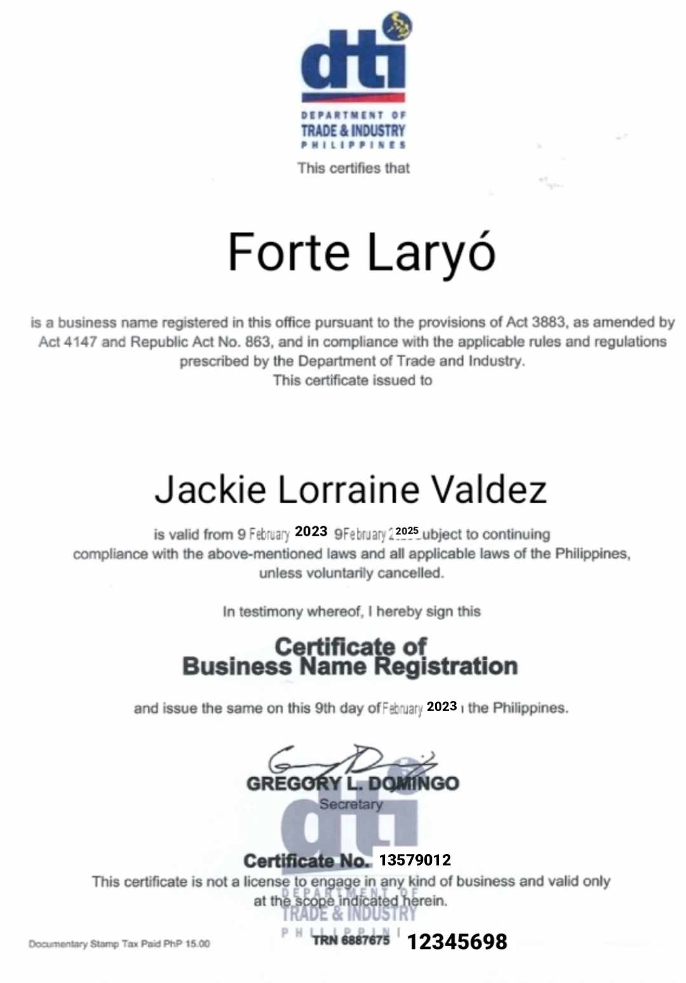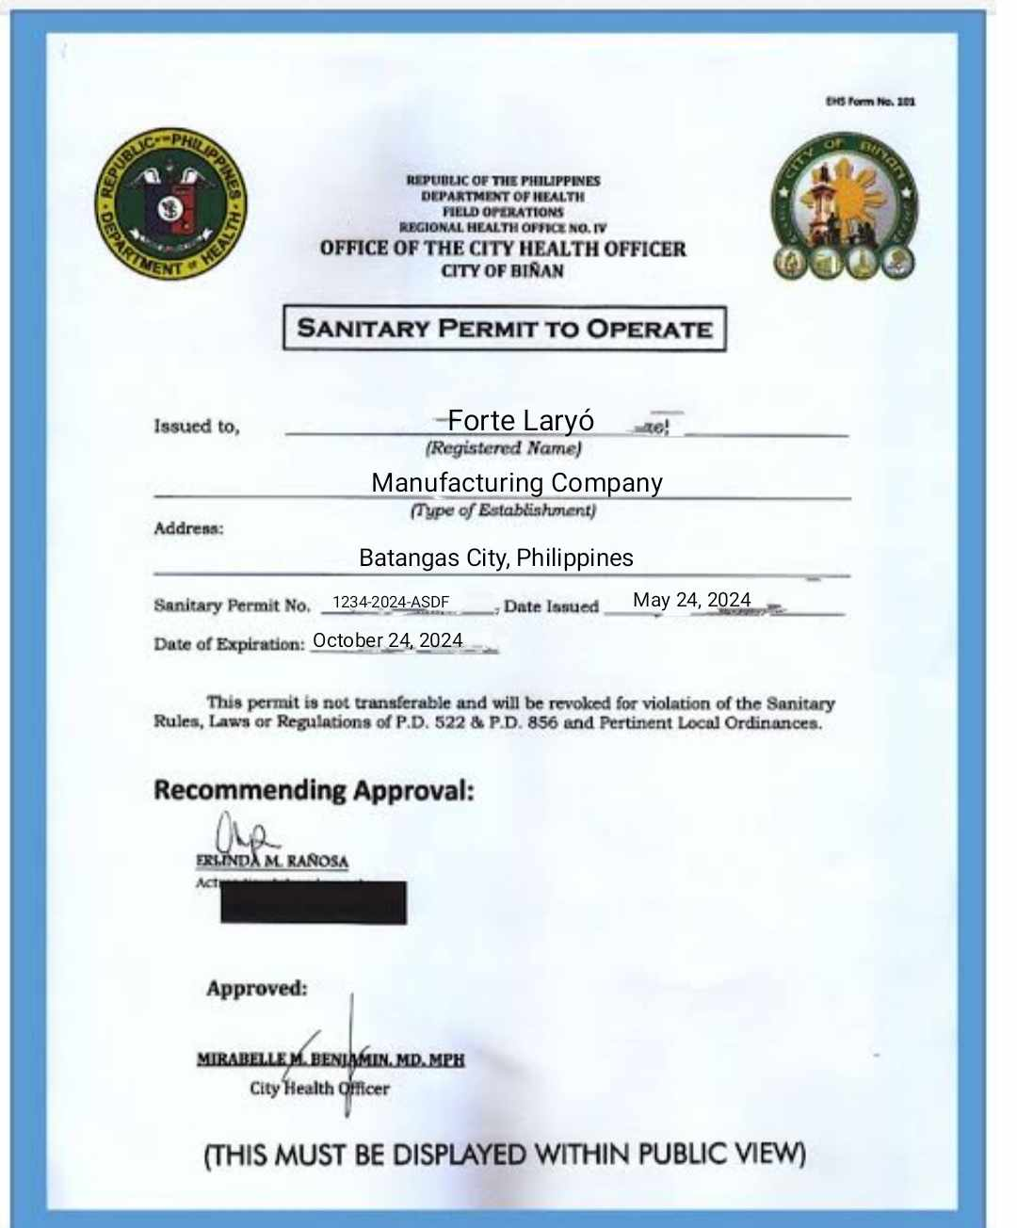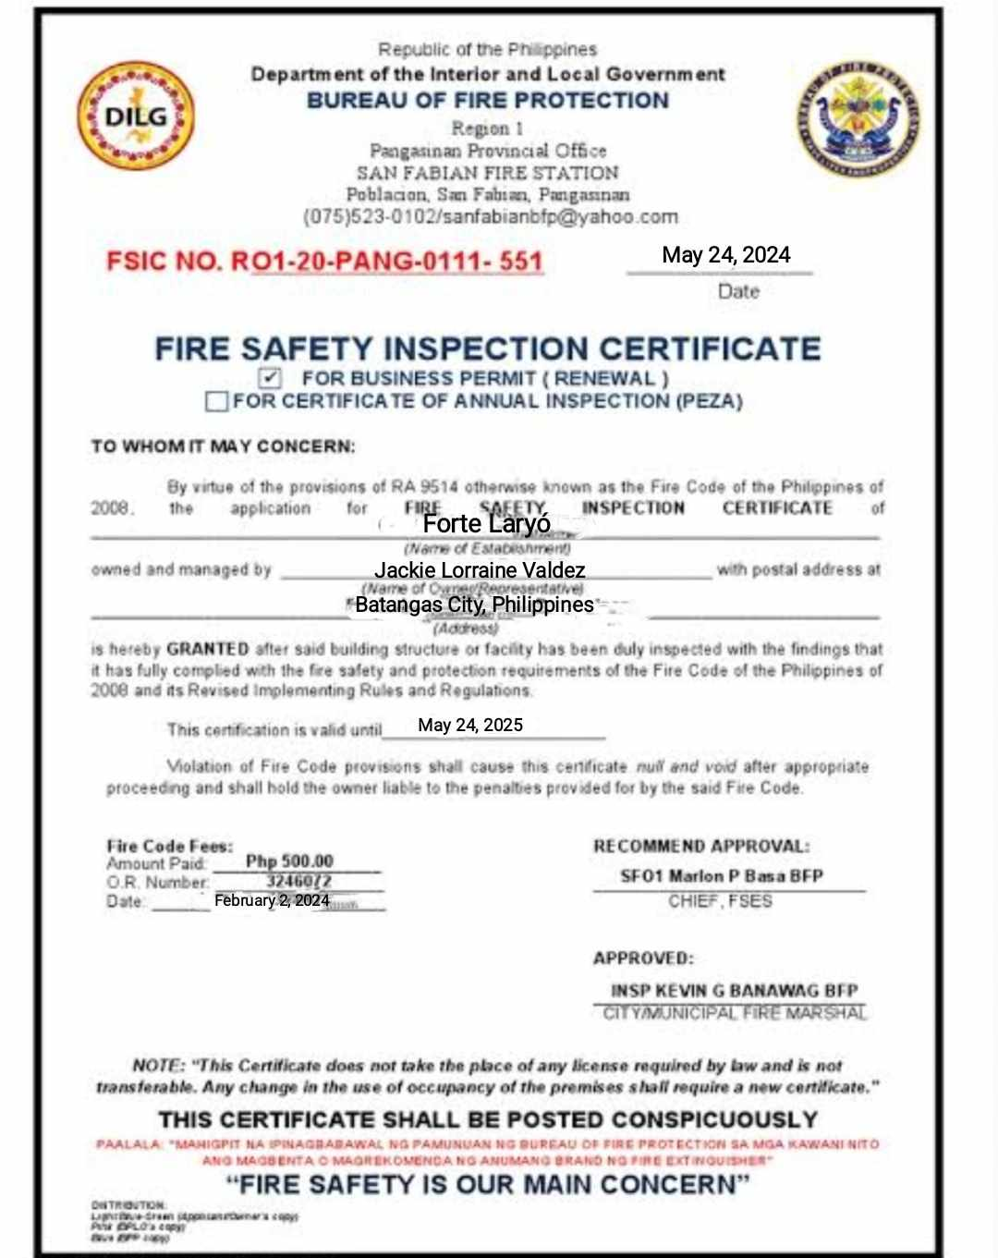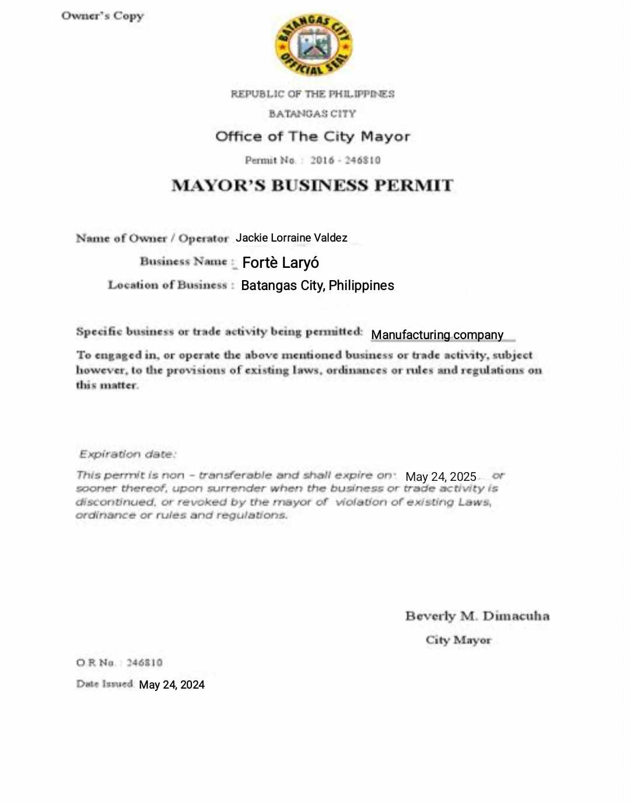

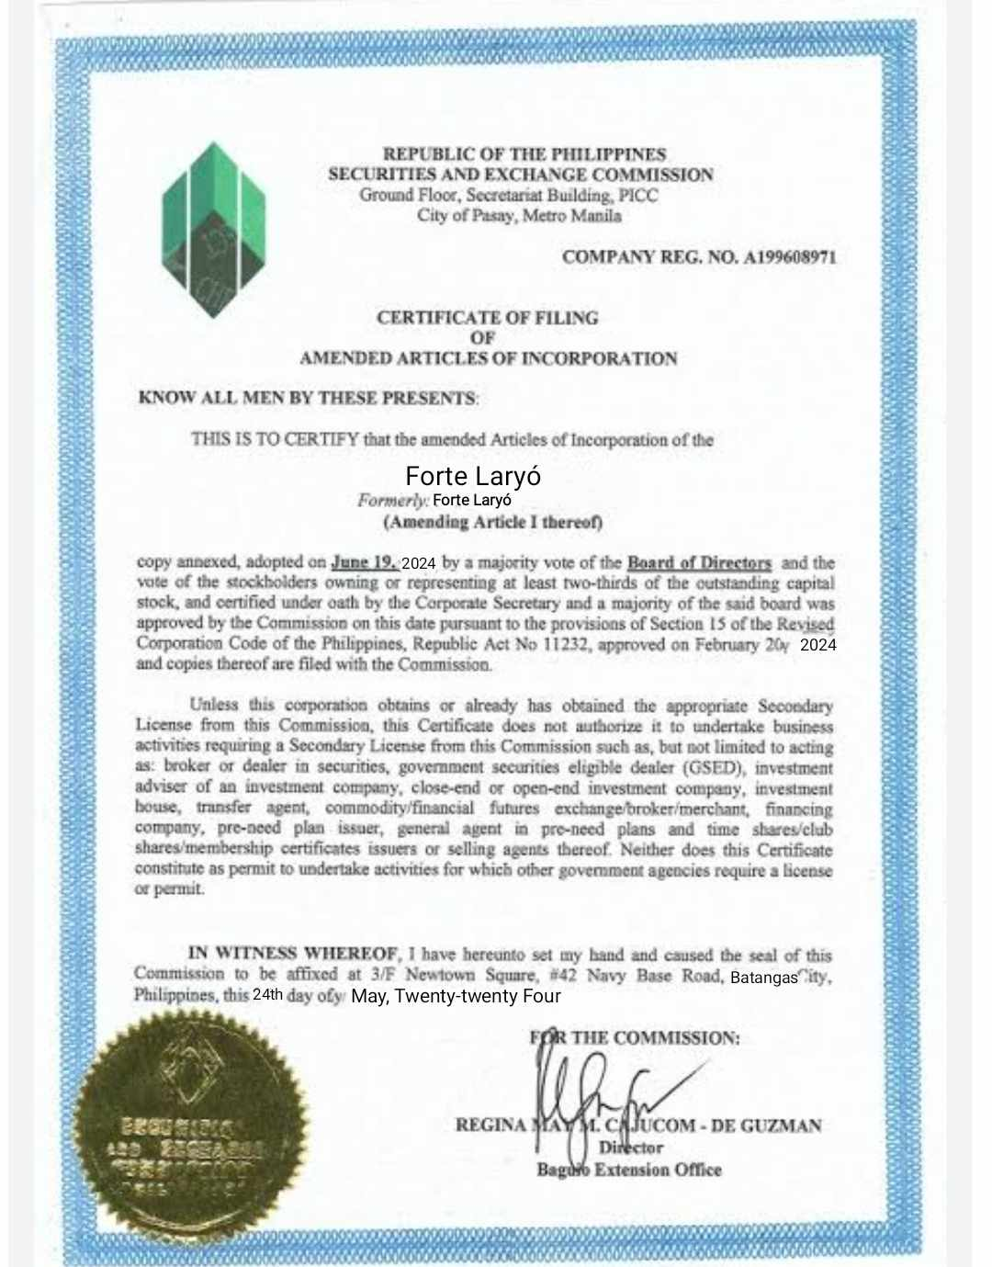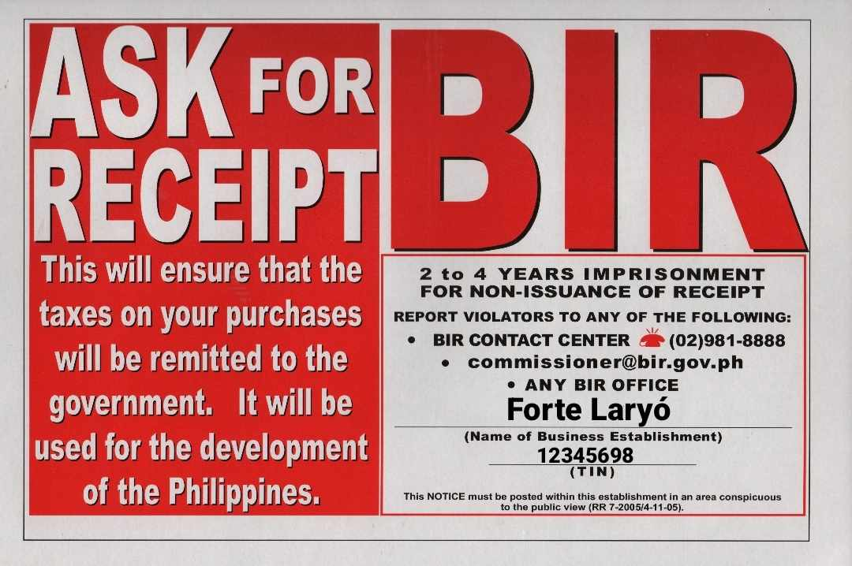

***5.2 Description of the logo and other promotional paraphernalia.***

Forte Laryó's logo features their initials in black and white, overlaid with two intersecting hammer silhouettes with reduced opacity, set against a blue-sky backdrop with black brick buildings. The two hammers symbolize the company's products—building materials. The buildings under the clear blue sky convey the company's goal of providing sturdy building materials while striving to preserve nature.

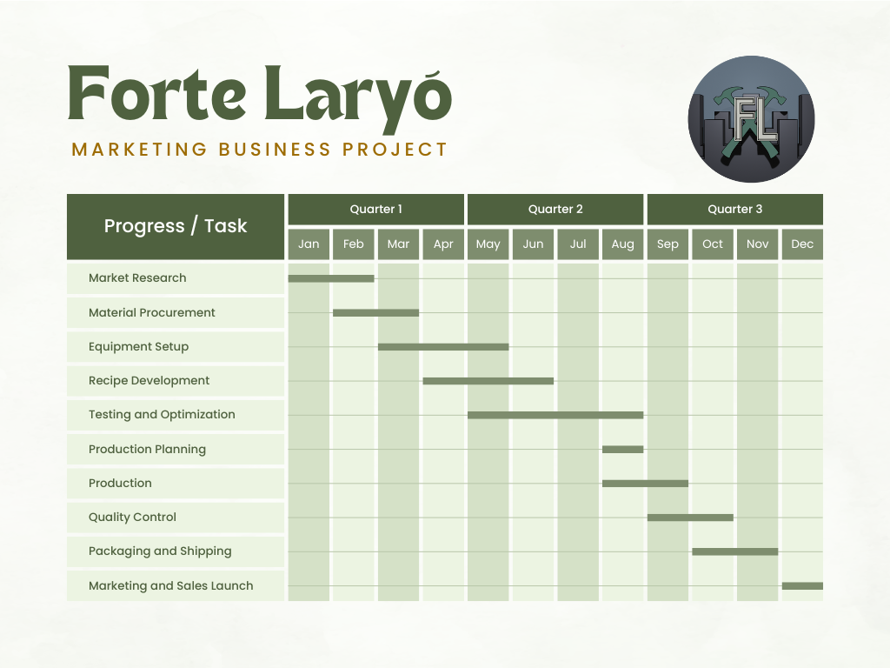***5.3 Management Schedule (GANTT Chart) and other management activities.***